Short on Political Cash
Some New York Congressional Representatives Posted Meager Campaign Receipts
By DEVLIN BARRETT

OCTOBER 24, 2011

A handful of city congressional Democrats raised precious little campaign money in recent months, even as they head into a year of uncertainty over district boundaries, a new election calendar and possible opponents.

According to the latest Federal Election Commission filings, three raised less than $50,000 during the three-month period ended Sept. 30: Reps. Yvette Clarke, Gary Ackerman and Jose Serrano.

And four—Ms. Clarke, Mr. Serrano, Rep. Edolphus Towns, and Rep. Greg Meeks—reported less than $50,000 in total campaign cash on hand with the election about a year away.

The lack of campaign funds comes at a time when lawmakers are concerned about what their district boundaries will look like after Albany legislators and Gov. Andrew Cuomo agree on a redistricting plan. The state's primary is also likely to change from its traditional date in September, leaving them vulnerable to a primary challenge as early as June.

There is plenty of time for lawmakers to build their accounts, and all hold traditionally safe Democratic seats. Two of them, Messrs. Serrano and Ackerman, have a history of dormant fund raising followed by bursts of activity in election years.
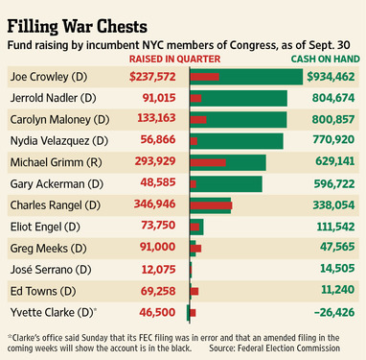

But the paucity of donations struck some observers as a sign of potential weakness.

Mr. Meeks, whose representatives didn't immediately respond to a request for comment, is facing a federal probe into whether he should have disclosed some personal loans. Ms. Clarke's reports showed her campaign was $26,000 in debt, though her campaign said Sunday its filing was in error. Her coffers are "in the black," the campaign said, without saying how much it had in the bank.

The cash problems aren't a problem for all New York lawmakers. Rep. Charles Rangel, a Democrat from Harlem, pulled in $346,945.94 during the same three-month period.

The lawmaker with perhaps the most intriguing fund-raising numbers is Mr. Towns, a 14-term incumbent representing central Brooklyn. Speculation has long swirled about whether the 77-year-old plans to retire. And this time, he could face a tough primary challenge from Assemblyman Hakeem Jeffries.

Mr. Towns raised about $70,000 last quarter, but has just $11,240.31 cash on hand. Douglas Muzzio, a professor of politics at Baruch College, said it would stand to reason that Mr. Towns would be "raising money like a bandit" if he planned to take on Mr. Jeffries. "But if that's not happening, one possible explanation is that he's looking to get out,'' Mr. Muzzio said.

A spokesman for Mr. Towns did not respond to an email seeking comment Sunday. Mr. Towns is a veteran politician who has survived primary challenges before and proven himself a formidable fund raiser.

However, at the comparable point in the last election cycle—October 2009—he had more than $200,000 in the bank, and had raised $252,311 in the quarter, more than three times what he raised this past quarter.

Mr. Ackerman, who represents a district straddling northern Queens and Nassau County, said the latest fund-raising numbers weren't a concern for him. He said he typically waits until an election year to raise money, and then hauls in about $1 million handily. Even with a slow start, he has more than half a million in his campaign account.

"I usually raise all my money in the home stretch," he said.

But Mr. Ackerman noted this would not be a typical election year. Redistricting can be a campaign expense. The new district lines will be drawn by the state Legislature, or a court if the Legislature can't agree with Mr. Cuomo. That process begins in earnest next year, and lawmakers often pay lobbyists to try to influence the outcome.

Separately, the federal government is pushing New York to have an earlier primary to comply with a law requiring military ballots be sent sooner to ensure such votes are counted.

"There's a tremendous unknown right now,'' Mr. Ackerman said. "Not only don't we know when the election is, we don't even know who will be inside our district. So we don't know who, and we don't know when.''

